Game Design Document

Fill up the following document

1. Write the title of your project.

Corona warrior

1. What is the goal of the game?

To kill all the virus and their symtyms

1. Write a brief story of your game.

One day in world of piece there comesa lonely demon called corona. He wants the world to be infected. When he starts

1. Which are the playing characters of this game?

* Playing characters are the ones who respond to the user based on the input from the user.
* Cars, monkeys, dinos, wizards, etc., are the playing characters in the game.

|  |  |  |
| --- | --- | --- |
| Number | Character Name | What can this character do? |
| 1 | hero | He flys and protects the world from infections. |
| 2 | dragon | He flys and protects the world from infections. |
| 3 |  |  |
| 4 |  |  |
| 5 |  |  |
| 6 |  |  |
| 7 |  |  |
| 8 |  |  |

1. Which are the Non-Playing Characters of this game?

* Non-Playing characters are the ones that don't have an action or behavior when the user interacts with the game.
* Hurdles, stones, bananas, coins, etc., are non-playing characters in the game.

|  |  |  |
| --- | --- | --- |
| Number | Character Name | What can this character do? |
| 1 | monster | Spreads the infection and controls his slaves |
| 2 |  |  |
| 3 |  |  |
| 4 |  |  |
| 5 |  |  |
| 6 |  |  |
| 7 |  |  |
| 8 |  |  |

Draw your imagination of this game. What does this game look like?

* Draw the game either on your computer or on paper.
* Add images of the game scenes to show each of the playing and non-playing characters at least once.

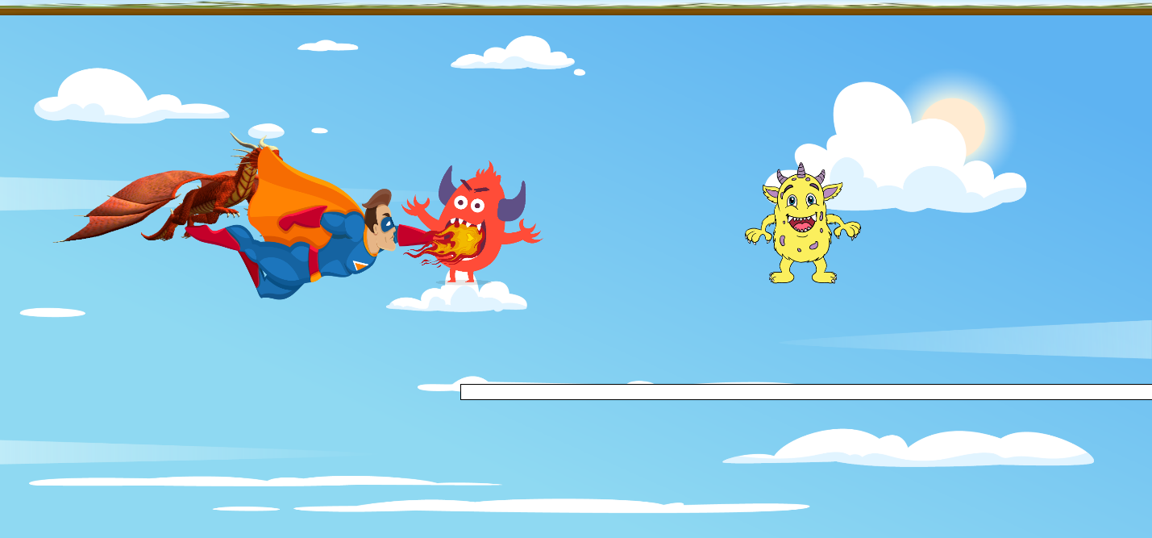

How do you plan to make your game engaging?

By using variuos sound and musics.